Feature image:"Gift Custom Jewelry—Touch a Heart Today!"

Title: The Emotional Impact of Gifting Custom Design Jewelry
Focus Keyword: Custom Design Jewelry
Secondary keyword:
Affordable Fine Jewelry
lab grown diamond jewelry
Shop jewelry online with Acima
Acima Leasing for Jewelry

Word count: 1000
Internal link:
best jewelry store in Albuquerque, NM: https://crownjewelsandcoin.com/
Engagement rings for women: https://crownjewelsandcoin.com/collections/engagement-rings

Meta Description:
Create lasting memories with custom design jewelry from Crown Jewels and Coin in Albuquerque. Affordable, unique pieces crafted with expert craftsmanship.
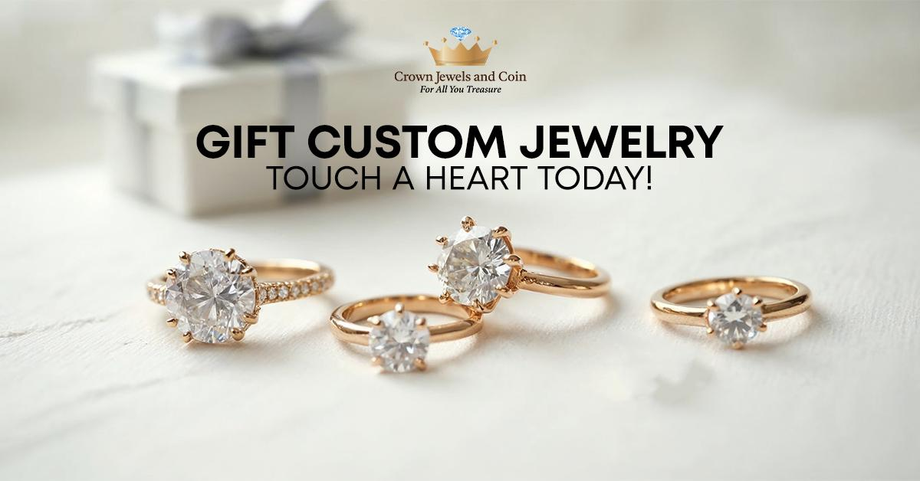

The Emotional Impact of Gifting Custom Design Jewelry H1

Jewelry as a gift is a perfect source to showcase your stature and emotions. Considering the fact that the world is filled with numerous replicas, the individual custom design concept of jewelry is one of the most inspiring ways to transfer warm emotions and genuine feelings. Here in this blog, we will talk about the emotional impact of gifting custom design jewelry and why it is very special for the recipient.
Let’s understand the reasons behind the appeal of customized jewelry as a gift.

Unparalleled Appeal of Jewelry:
Since ancient times, jewelry has been a part of the gifts that people hold dear in their lives because these pieces signify affection or appreciation. Whether it is an engagement ring for a lady, a corporation mark, or a bracelet on an anniversary, every jewelry item is always special. Custom design jewelry goes a notch higher by adding the next level of specific characteristics that relate to the wearer. Such personalization gives people an emotional connection between the giver and the recipient. If you want to buy timeless jewelry, then visit Crown Jewels and Coin, the best jewelry store in Albuquerque, NM.

Uniqueness and Personalization H2
As you have the option to create custom-made jewelry, you can gift pieces of jewelry that cannot be compared to those that come from anonymous production lines. When you are gifting an item that costs a specific design and the taste of the recipient has been put into consideration, then the recipient will understand that you have spared time to select the gift. When it comes to the selection of the type of diamonds for your custom engagement rings, try to purchase lab-grown diamonds exclusively to select an amusing design that both of you would like or a symbolic one. This not only adds some romantic characteristics to the classic product but also makes the piece remain admired by future generations.

Create Emotional Connection H2
The concept of breathing life into the piece of jewel that eventually becomes an integral part of your loved one's life routine and always carries a different level of emotional appeal. This emotional connection ultimately creates a meaningful connection between you and your loved ones that will last for years to come. Crown Jewels and Coin designers will allow you to discuss passions and develop a design that is important to you. Through this, an attachment is created and there is more meaning behind the piece being created. In the same way, the recipient can receive the warmth of this relationship when they know that the piece was made for them only.

Build Lasting Memories H3
It is not a secret that people view custom pieces as a means to preserve memories. If you purchase a custom ring for your lady, it will signify your commitment every time she wears that gift during engagement events and weddings. Gradually, such gifts are linked to the kind of feelings, events and occasions that they symbolize. This link to beloved memories makes a piece of jewelry even more sentimental, which makes it very special and not just an ornamental accessory. It becomes a representation of your love, devotion, and unique story.

Bring Value Along With Affordability H3
At Crown Jewels and Coin, we realize that the current price cannot and should not be the reason for a gift but the warmth it brings. This is why we provide beautiful pieces of affordable fine jewelry without compromising the standard of the item. This means you can affordably sourced lab grown diamond jewelry from us without compromise on the quality of the piece. Through this availability of cheap filigree jewelry, you will be in a position to show your love as well as care in the form of jewelry with limited cash strain.

Why Choose Crown Jewels and Coin for Customs Jewelry? H3

Crown Jewels and Coin stands among the leading jewelry retailers in Albuquerque, NM. Our personalized service experience belongs to the highest standards, which we maintain through our staff's customer interactions. Our team of professionals handles both the best treatment of clients and the delivery of premium quality work output. We provide assistance to our customers who seek engagement rings for women or any other custom jewelry piece. Due to our wide offer of cultured diamonds and the ability to adjust the design, you can now make a piece as unique as you and your soul.

Shop Jewelry Online with Acima H3
It can hardly be overestimated how helpful is the opportunity to purchase jewelry online. Crown Jewels and Coin has integrated with Acima to provide affordable monthly payment for the customers who want to purchase custom design jewelry as gifts. Acima leasing for jewelry enables you to use the jewels as you make payments for a particular period. This makes it easy for you to enjoy a performance of gifting customized jewelry of any value.

Expert Craftsmanship and Personalized Service H3
Crown Jewels and Coin deliver exceptional workmanship and services based on their deep knowledge of customer requirements. Each custom jewelry piece at Crown Jewels and Coin is crafted through team collaboration between our professional jewelers and customers to achieve satisfying results. Our experts guarantee your complete satisfaction with the final product from selection through to purchase completion.

Final Thoughts H3
In a world where relationships may seem absent and filled with superficiality, it is very fulfilling to give custom design jewelry pieces. Whether it is an engagement ring set for women, a simulated diamond necklace or a charm bracelet, such jewelry has a completely different meaning from that of the jewelry bought in a supermarket. Crown Jewels and Coin take pride in providing you with the ideal piece that will cater to all your love and passion. For those who are fond of fine jewelry, we now make it easier to get one that would be a perfect gift through Acima, which offers affordable fine jewelry purchased online.
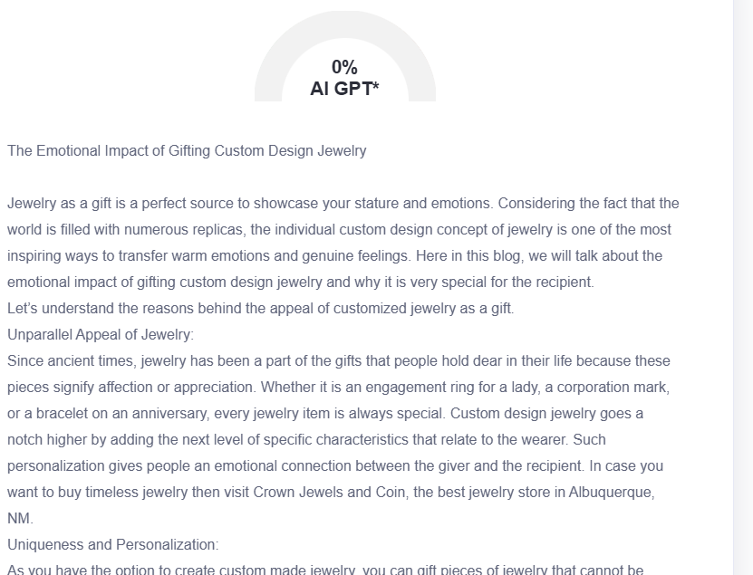

GMB
At Crown Jewels and Coin, we recognize that jewelry represents more than just pieces as it allows customers to demonstrate their deepest feelings through personalized gifts. When you choose custom design jewelry, your sentiment grows stronger because the pieces reflect the individuality of your relationship. The time you dedicated to creating each personalized piece stands out through our custom designs, as each piece demonstrates the personalized selection you made. At our premier Albuquerque jewelry destination, we create precious symbols of memorable moments, which include wedding commemoration rings together with anniversary bracelets for commemorating your mutual journey. Your jewelry pieces become important to everyday life because they build an emotional connection between you and your loved ones and continually remind them of your special bond. Expert craftsmen on our team work hand-in-hand with customers to develop your unique vision into wearable pieces of art that speak about your personal history. You can now give custom jewelry gifts through Acima leasing so people can pay in monthly installments for luxury purchases at important moments. Crown Jewels and Coin enables customers to transform personal emotions into permanent treasures through their skilled design of engagement rings and heirloom items. The personalized service standard at our location enables professionals to create special jewelry for you to manifest lasting memories through gleaming tangible pieces of your most precious relationships.

